**Jenkins CICD pipeline screenshots**

1. Create a VM in Amazon Could to install Jenkins and Docker

1. Verify Jenkins is installed

1. Verify Docker is installed

1. Create a Jenkins **Continuous Integration** pipeline and name it **dockerimg**

1. Verify apache2 is installed

1. **Trigger the docker commands using Dockerfile using CI pipeline**

1. **Verify** the new docker image is created and pushed to docker hub

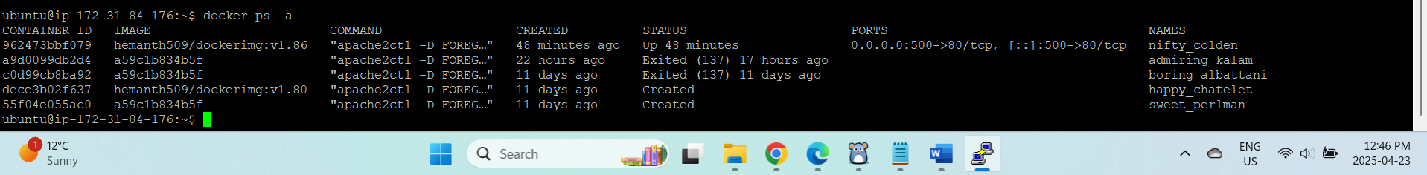

**Verify CI pipeline is successful**

1. **Verify the CD pipeline is successful**

1. **Verify the CD pipeline is successful**

**Docker image pull was successful on another web app server running on port 500**

